**ME 111 Engineering Drawing**

**Section of solids Tuesday Batch**

**Q.1** A cone with base 75 mm diameter and axis 80 mm long is resting on its base on H.P. It is cut by a section plane perpendicular to the V.P., inclined at 45º to the H.P. and cutting the axis at a point 35 mm from the apex. Draw the front view, sectional top view, sectional side view and true shape of the section. [20 marks]

{Note: Please don’t cut the marks if the student divides the base circle into 6 or 8 equal number of parts. Dividing the circle into 4 equal parts is not to be accepted as 4 points are not sufficient to give the proper views of sections.}

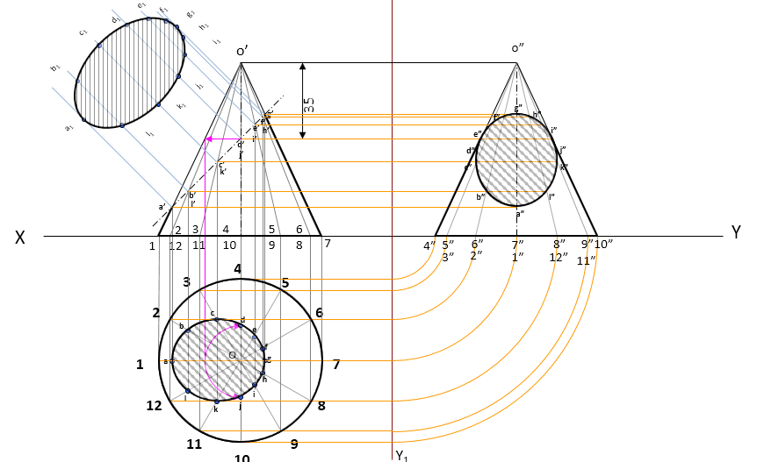

**Q.2** A hexagonal prism is resting on one of its edges of base and its axis is inclined at 45° to HP. A section plane cuts the axis at a distance of 15 mm away from one of its ends. The section plane is perpendicular to HP and makes 45° to VP. If the smaller cut-part is removed, then draw the top view, sectional front view of the remaining solid and the true shape of the section. [30 marks]

